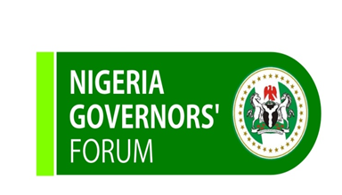

NGF Secretariat, 1, Deng Xiaoping Street, AIT Junction, Asokoro, Abuja, Nigeria.
www.nggovernorsforum.org
(+234-9-8703927; +234-9-8703928)

PRESS RELEASE

Congratulations to His Excellency, Governor Olusegun Mimiko

The Nigeria Governors’ Forum (NGF) heartily congratulates Dr. Olusegun Mimiko, the Executive Governor of Ondo State on his re-election in the just concluded gubernatorial elections held on Saturday, October 20, 2012.

His Excellency, Dr. Mimiko has been an active and member of the Forum, making immense contributions at every juncture. We are delighted that his people have re-affirmed their faith in him by ensuring his victory at the polls.

We urge all those who ran with Governor Mimiko in the just concluded elections to join hands with him in building a strong Ondo State bearing in mind that governance is a collective effort. This mandate gives His Excellency the opportunity to build on and complete all the excellent projects started in the past years.

While we rejoice with Dr. Mimiko and his family in their moment of glory, we wish to remind him that a lot of work remains to be done and we urge more grease to his elbow.

Long Live Democracy!
Long Live Ondo State!
Long Live the Federal Republic of Nigeria!

A.B. Okauru
Director General
Nigeria Governors’ Forum

